2.4 Relative Clauses

Vocabulary

Form | Meaning | Count | Rank | POS
ἅτε | just as if | 26 | 298 | adv
οἷος | of what sort | 43 | 187 | adj
ὁπόσος | of whatever number | 22 | 346 | adj
ὁπότε | whenever | 22 | 345 | adv
ὅπου | wherever | 21 | 374 | adv
ὅπως | however | 90 | 95 | adv
ὅς | who | 439 | 16 | adj
ὅσος | as many as | 115 | 70 | adj
ὅστις | whoever | 42 | 193 | adj
τοιοῦτος | such | 50 | 157 | adj
τοσοῦτος | so many | 24 | 328 | adj

Correlative pronouns/adjectives [Smyth 340]

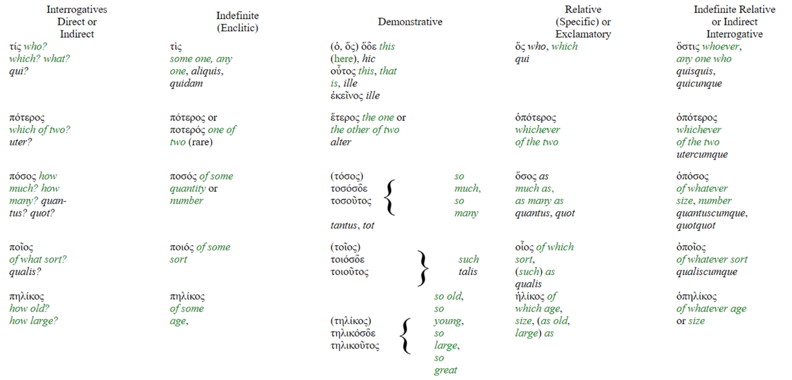

Correlative adverbs [Smyth 346]

